**GES1009/SSA2203**

**AY2018-19**

**TUTORIAL ONE**

In this round of tutorials, we will explore the features of Singapore as an early colonial entrepôt.

**Readings:** Stephen Dobbs, *The Singapore River: A Social History 1819-2002*, Chapter Two “The River: Development of an economic landscape”

Look also at the maps from Dobb’s book (available via the IVLE)

Bring along your readings for week 3 (on various trading communities)

**QUESTIONS FOR DISCUSSION:**

1. What do you see as some of the key features of Singapore’s early years as a trading settlement?
2. What types of commodities moved through Singapore and how does this help us understand the business environment?
3. Traders and officials: how might their views of the Singapore River differ? What were their main concerns (priorities) with the early settlement and business environment?

Look at the Morgan Chua cartoon from *Divercity Singapore: A Cartoon History of Immigration,* (2010)entitled “Free Port Fever”. (This is a cartoon originally spanned two pages)

1. Imagine this cartoon has been recommended for inclusion in a textbook on Singapore’s business history. Would you support this recommendation? Why or why not? (Critique the cartoon).

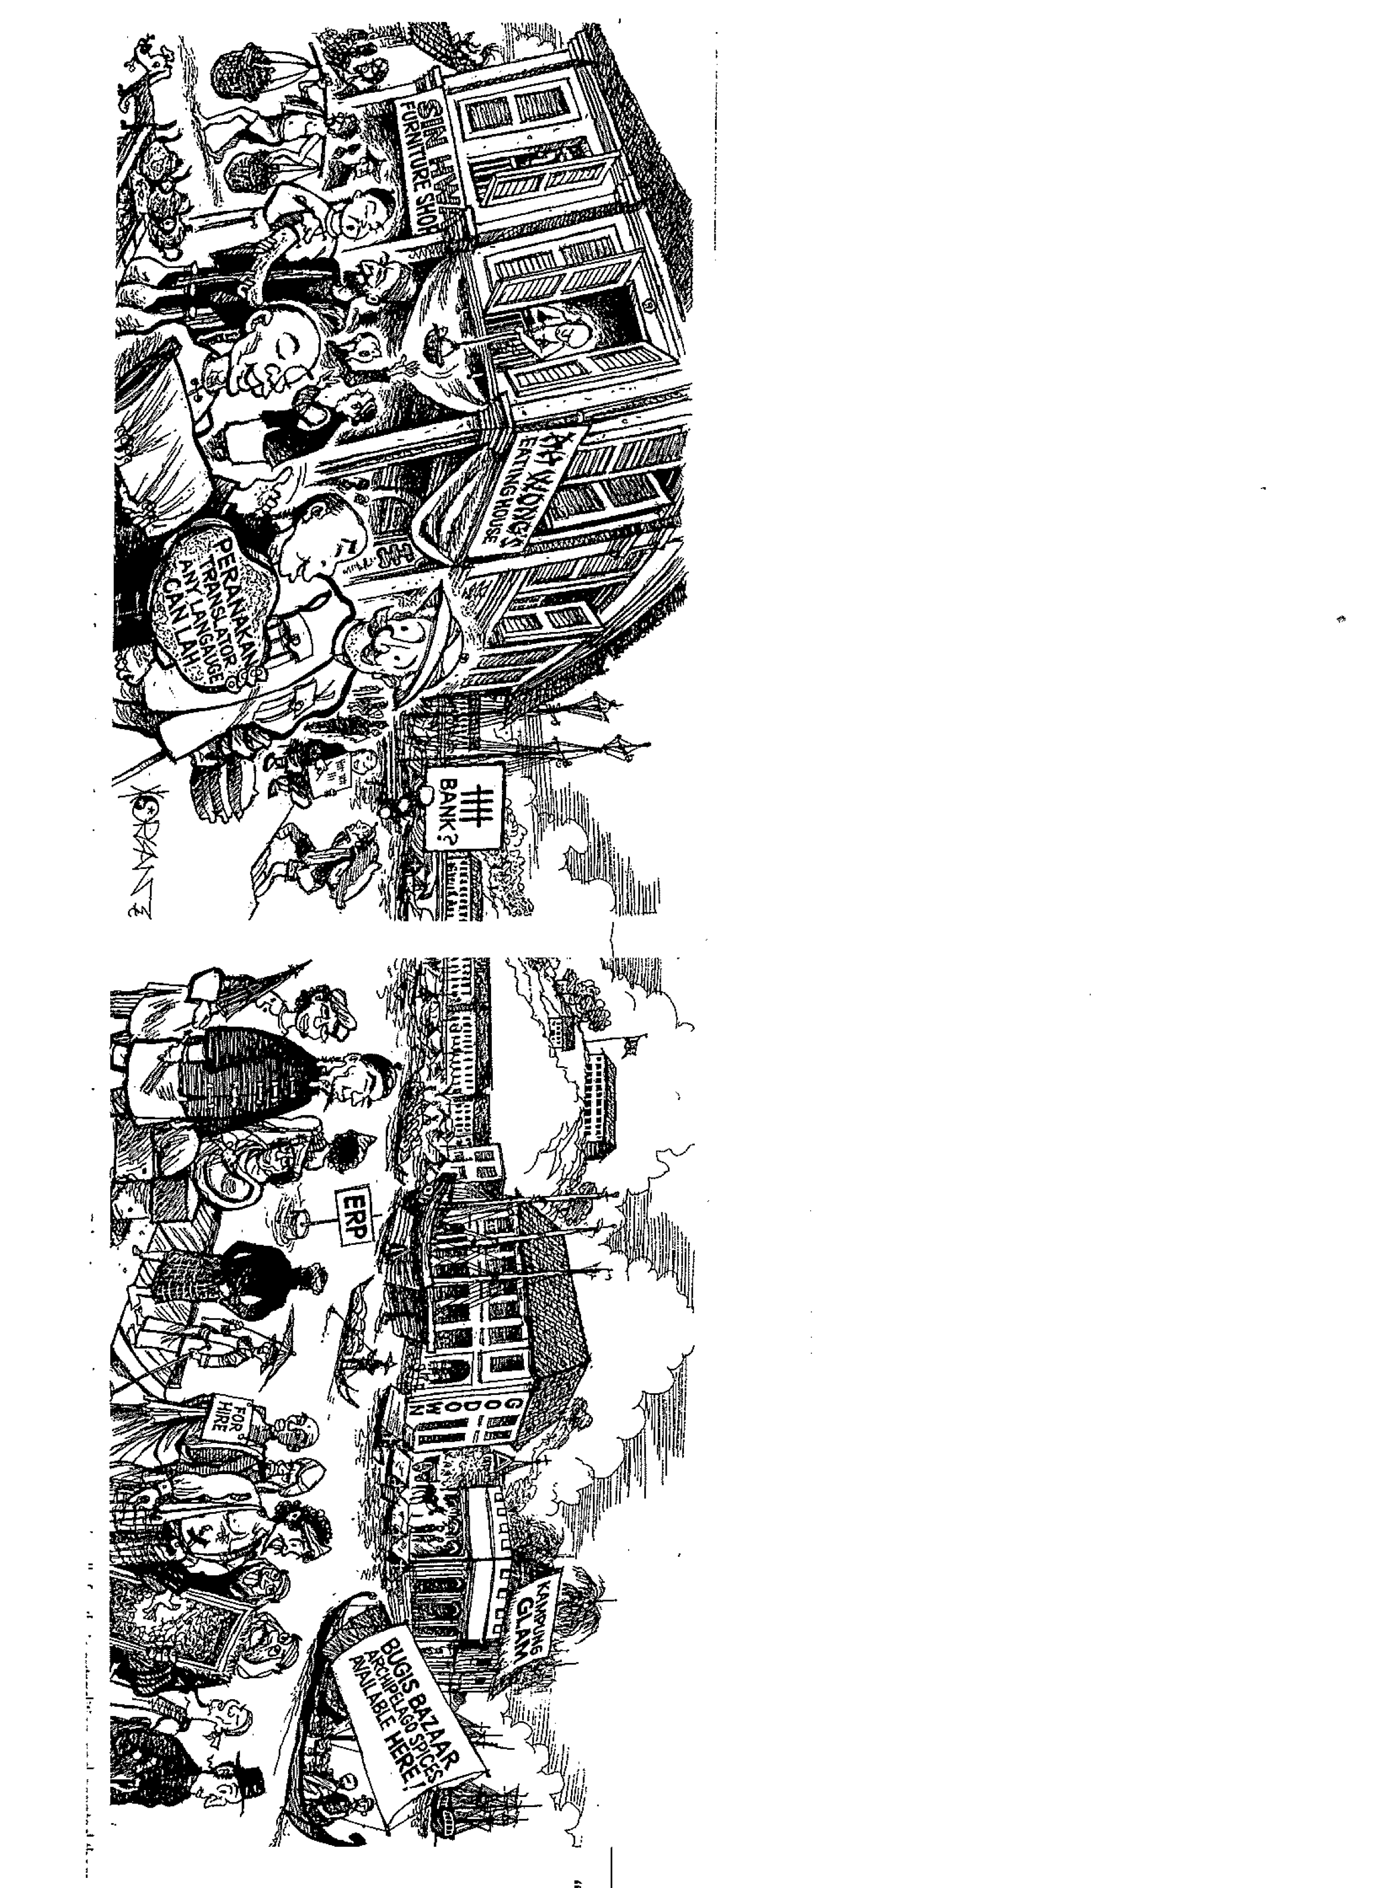

Morgan Chua, “Free Port Fever” 2010.